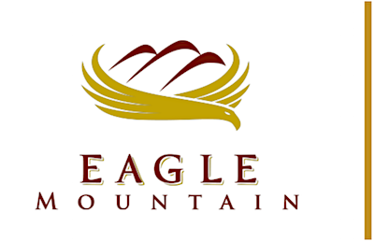 | EAGLE MOUNTAIN  REDEVELOPMENT AGENCY BOARD MEETING Agenda
September 03, 2019, 7:00 PM
Eagle Mountain City Council Chambers
1650 E Stagecoach Run, Eagle Mountain, Utah 84005

REDEVELOPMENT AGENCY BOARD MEETING - CITY COUNCIL CHAMBERS

1. CALL TO ORDER

2. MINUTES

2.A. | June 18, 2019 Minutes  Redevelopment Agency Board Meeting  2019-06-18 RDA Minutes - DRAFT
3. RESOLUTIONS

3.A. | RESOLUTION - A Resolution Approving a CRA Participation Agreement between the Redevelopment Agency of Eagle Mountain City and Eagle Mountain City, Oquirrh Wood Ranch, LLC, Utah County and Tyson Fresh Meats, Inc.  BACKGROUND: ( Presented by City Staff) The proposed agreement details the allocation of tax increment from the Pole Canyon Community Reinvestment Area.  RES--Pole Canyon CRA Participation Agreement with Tyson Meats, Inc.  Participation Agreement DRAFT 8-28 (00452166xB00C1)
4. ADJOURNMENT

CERTIFICATE OF POSTING

The undersigned, duly appointed City Recorder, does hereby certify that the above agenda notice was posted on this 29th day of August, 2019 on the Eagle Mountain City bulletin boards, the Eagle Mountain City website www.emcity.org, posted to the Utah State public notice website http://www.utah.gov/pmn/index.html, and was emailed to at least one newspaper of general circulation within the jurisdiction of the public body.
Fionnuala B. Kofoed, MMC, City Recorder

