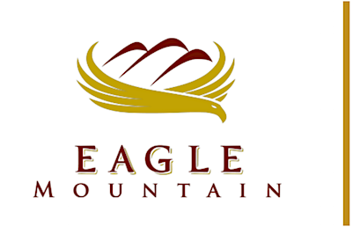 | EAGLE MOUNTAIN  REDEVELOPMENT AGENCY BOARD MEETING
June 18, 2019, 8:00 PM
Eagle Mountain City Hall
1650 E Stagecoach Run, Eagle Mountain City, UT 84005

REDEVELOPMENT AGENCY BOARD MEETING - CITY COUNCIL CHAMBERS

1. CALL TO ORDER

2. MINUTES

2.A. | May 21, 2019 Minutes  Regular Redevelopment Agency Board Meeting  05.21.2019 RDA Minutes - DRAFT
3. RESOLUTION/PUBLIC HEARING

3.A. | RESOLUTION - A Resolution of the Redevelopment Agency of Eagle Mountain City Amending the Fiscal Year 2018-2019 Budget - Final Amendment.  BACKGROUND: (Presented by Assistant City Administrator Paul Jerome) State statute requires the RDA to amend its budget to appropriate funds for increased expenses. The proposed resolution is the final budget amendment for Fiscal Year 2018-2019.  FY2019 RDA Budget Amendments  RES--FY 2019 Budget Amendment
3.B. | RESOLUTION – A Resolution of the Redevelopment Agency of Eagle Mountain City, Utah, Adopting the Fiscal Year 2019-2020 Budget.  BACKGROUND: (Presented by Assistant City Administrator Paul Jerome) State statute requires the Board to hold a public hearing on the tentative budget and that the budget be adopted by June 22. The tentative budget was accepted by the Board on May 7, 2019. The final budget will be the document that governs the expenditures for FY 2019-2020.  2020 Budget (RDA) - FINAL  RES--FY 2020 RDA Budget Adoption
4. ADJOURNMENT

CERTIFICATE OF POSTING

The undersigned, duly appointed City Recorder, does hereby certify that the above agenda notice was posted on this 13th day of June, 2019, on the Eagle Mountain City bulletin boards, the Eagle Mountain City website www.emcity.org, posted to the Utah State public notice website http://www.utah.gov/pmn/index.html, and was emailed to at least one newspaper of general circulation within the jurisdiction of the public body.
Fionnuala B. Kofoed, MMC, City Recorder

