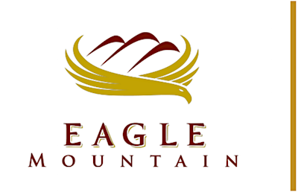 | EAGLE MOUNTAIN  Redevelopment Agency  Board MEETING
March 05, 2019, Directly Following City Council Meeting
Eagle Mountain City Council Chambers
1650 East Stagecoach Run, Eagle Mountain, Utah 84005

17. REDEVELOPMENT AGENCY MEETING - CITY COUNCIL CHAMBERS

18. CALL TO ORDER

The City Council will convene as the Board of Directors of the Eagle Mountain City Redevelopment Agency.

19. RESOLUTIONS

19.A. | RESOLUTION - A Resolution of the Redevelopment Agency of Eagle Mountain City, Utah, Appointing Officers to Serve in the Redevelopment Agency of Eagle Mountain City.
19.B. | RESOLUTION - A Resolution of the Redevelopment Agency of Eagle Mountain City, Utah, Designating a Survey Area Known as the Pole Canyon Survey Area #1, and Authorizing Agency Staff, Consultants and Legal Counsel to Prepare a Proposed Community Reinvestment Project Area Plan, and Accompanying Project Area Budget for a Proposed Community Reinvestment Area within the Survey Area.  BACKGROUND -- (Presented by Aaron Sanborn, Economic Development Manager) The proposed resolution gives the agency staff, consultants and legal counsel authorization to prepare a plan and budget for the project area.
20. ADJOURNMENT

CERTIFICATE OF POSTING

The undersigned, duly appointed City Recorder, does hereby certify that the above agenda notice was posted on this 28th day of February 2019 on the Eagle Mountain City bulletin boards, the Eagle Mountain City website www.emcity.org, posted to the Utah State public notice website http://www.utah.gov/pmn/index.html, and was emailed to at least one newspaper of general circulation within the jurisdiction of the public body.
Fionnuala B. Kofoed, MMC, City Recorder

